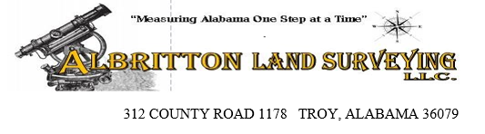
NAME:
PHONE:
EMAIL:
PARCEL ID (OPTIONAL):
COUNTY:
# OF ACRES:

CHECK BOXES THAT APPLY:
PERCOLATION VIABILITY TEST ☐
LOT SURVEY ☐
BOUNDARY SURVEY ☐
TOPO SURVEY ☐
LINES STAKED ☐
CUT OUT ☐
ALTA SURVEY ☐
OTHER:

